CAN-St Johns Indian Village-W. H. Bartlett-1842

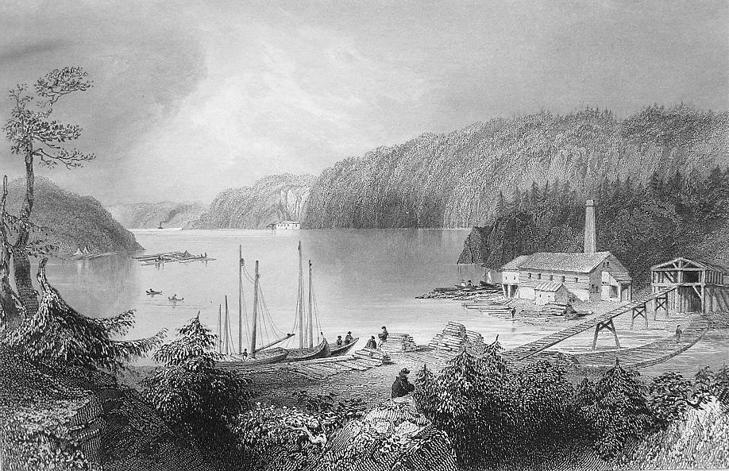

* **Year of printing:** 1841-1842
* **Original artist:** W.H. Bartlett
* **Publisher:** Proprietors Geo Virtue at 26 Ivy Lane, London

Above the Falls of St. John, the expanded river forms a bay of some extent, surrounded by high and rugged woodlands. At the lower end of this bay, and a short distance from the falls, stands the picturesque village of Indian Town, which, owing to the hindrance of the navigation of the river by the Falls, has become a kind of lesser port to St. John, where numbers of small craft load and unload their cargos. The steamer for Fredericton also lies there; the distance to St. John being not more than a mile and a half, by a good road.